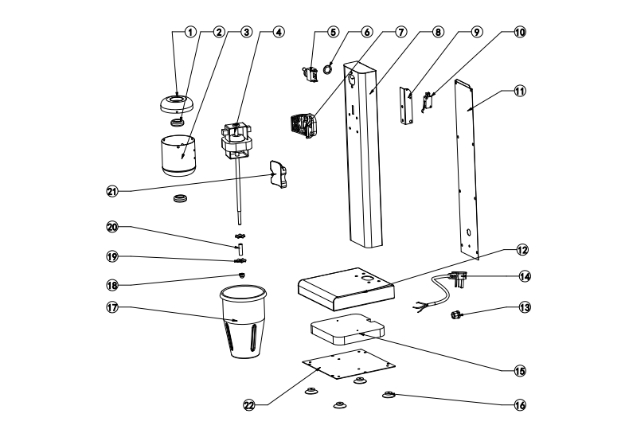

No. | Name | Qty. | No. | Name | Qty.
1 | Cover | 1 | 12 | Base | 1
2 | Silicagel | 2 | 13 | Cablehead | 1
3 | Enginecup | 1 | 14 | Powercable | 1
4 | Motor | 1 | 15 | Gravitationalplate | 1
5 | Three-speedswitch | 1 | 16 | RubberFeet | 4
6 | Screw | 1 | 17 | Milkshakercup | 1
7 | Plasticstent | 1 | 18 | ScrewM6 | 1
8 | Column | 1 | 19 | Rotor | 2
9 | Supportplate | 1 | 20 | Φ8tube | 1
10 | Microswitch | 1 | 21 | Plastichanger | 1
11 | BehindBoard | 1 | 22 | Baseboard | 1
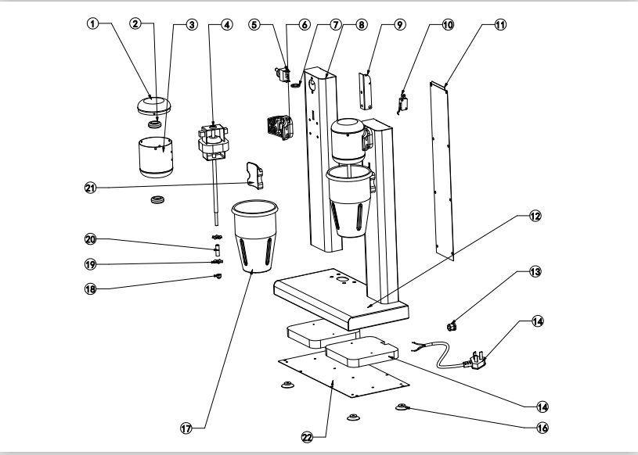
No. | Name | Qty. | No. | Name | Qty.
1 | Cover | 2 | 12 | Base | 1
2 | Silicagel | 4 | 13 | Cablehead | 1
3 | Enginecup | 2 | 14 | Powercable | 1
4 | Motor | 2 | 15 | Gravitationalplate | 2
5 | Three-speedswitch | 2 | 16 | RubberFeet | 4
6 | Screw | 2 | 17 | Milkshakercup | 2
7 | Plasticstent | 2 | 18 | ScrewM6 | 1
8 | Column | 2 | 19 | Rotor | 4
9 | Supportplate | 2 | 20 | Φ8tube | 2
10 | Microswitch | 2 | 21 | Plastichanger | 2
11 | BehindBoard | 2 | 22 | Baseboard | 1

